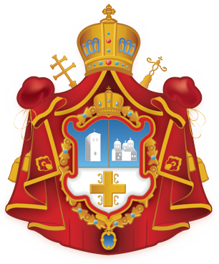

REGISTRATION FORM

ST SAVA DAY CAMP & VACATION SCHOOL
Sponsored by the Sydney Deanery of the
Serbian Orthodox Church – Metropolitanate of Australia and New Zealand
in cooperation with the Federation of Circles of Serbian Sisters
at the St George Parish Grounds
972 Bringelly Road, Rossmore NSW
Bright Wednesday, 15 April to Bright Friday, 17 April 2015

Open to Grades K to 6| Cost: $60 per camper (for 3 days):

Camper Name: _________________________________________________________ Date of Birth: _____ / _____ / _________ Gender: M / F
Address: _______________________________________________________________________________
Suburb: __________________________________ State: ________ Postcode: __________ Phone: ___ ___ ___ ___ -___ ___ ___- ___ ___ ___
Medicare Number: ___ ___ ___ ___ - ___ ___ ___ ___ ___ - ___
Please advise of any allergies and/or dietary requirements: ◻ Yes ◻ No _______________________________________________
Name/s of Parents/Guardians: _____________________________________________________________________________________________
Mother’s Mobile Number: ___ ___ ___ ___ -___ ___ ___- ___ ___ ___ Father’s Mobile Number: ___ ___ ___ ___ -___ ___ ___- ___ ___ ___
Our child will require minibus transportation from St Sava Church in Homebush West to the St George Parish Grounds ◻ Yes ◻ No

Signed: __________________________________________________________ Date: _____ / _____ / _________
Parent / Guardian Signature
This is a Day Camp & Vacation School of the Serbian Orthodox Church conducted in accordance
with the teachings of the Orthodox Church and Serbian traditions

Camper is baptised in the Orthodox Christian Faith? ◻ Yes ◻ No
Church Affiliation/Parish: __________________________________________________________________________________________________
Parish Priest’s Name: _____________________________________ ___________________________________ _____ / _____ / _________
Parish Priest’s Signature Date
I will be attending the St Sava Summer Camp from Wednesday, 15 April to Friday, 17 April 2015.
I am a school student enrolled at: ____________________________________________________ (name of primary or secondary school)
I understand there are certain rules and a code of conduct that I must abide by for the duration of the St Sava Day Camp (NSW).
Signed: __________________________________________________________ Date: _____ / _____ / ________
Camper Signature

To register:
- Complete this form by Easter Sunday, 12 April 2015, and send to:
Mrs Milica Kozlina, President FCSS
PO Box 512, Alexandria NSW 1435
or scan and e-mail to: fcss@soc.org.au
- Payment to be made on arrival (Day 1 of Camp) or by cheque, payable to SERBIAN ORTHODOX METROPOLITANATE
- Please ensure that your Parent/Guardian and Parish Priest sign this application form.

PROUD OF OUR ORTHODOX FAITH AND OUR SERBIAN HERITAGE AND LEARNING TOGETHER!

